TASK 1: Create a New VPC
Objective
Create a new Virtual Private Cloud (VPC) named InstaVibeVPC with the IPv4 CIDR block 10.0.0.0/16.
Steps Performed
- Logged in to the AWS Management Console.
- Opened the VPC Dashboard.
- Clicked Create VPC.
- Selected VPC Only.
- Entered the VPC name as InstaVibeVPC.
- Specified the IPv4 CIDR block as 10.0.0.0/16.
- Kept the tenancy as Default.
- Clicked Create VPC.
Configuration
Setting | Value
VPC Name | InstaVibeVPC
IPv4 CIDR Block | 10.0.0.0/16
IPv6 | None
Tenancy | Default
Result
The VPC InstaVibeVPC was created successfully and is ready for creating subnets and other networking resources.
Screenshot
(Paste your VPC creation screenshot here.)

Question 2: Create Public and Private Subnets
Objective
Create one public subnet and one private subnet inside InstaVibeVPC.
Steps Performed
- Opened the Subnets section in the VPC Dashboard.
- Clicked Create Subnet.
- Selected InstaVibeVPC.
- Created the first subnet with the name PublicSubnet-Zomato.
- Assigned the CIDR block 10.0.1.0/24.
- Created another subnet named PrivateSubnet-Zomato.
- Assigned the CIDR block 10.0.2.0/24.
- Clicked Create Subnet.
Subnet Details
Subnet Name | CIDR Block | Purpose
PublicSubnet-Zomato | 10.0.1.0/24 | Hosts public resources such as web servers
PrivateSubnet-Zomato | 10.0.2.0/24 | Hosts backend services and databases
Result
Both the public and private subnets were successfully created inside InstaVibeVPC.
Screenshot
(Paste your Subnets screenshot here.)

Question 3: Configure an Internet Gateway
Objective
Allow internet access only for the public subnet.
Steps Performed
- Opened the Internet Gateways section.
- Clicked Create Internet Gateway.
- Named it InstaVibe-IGW.
- Created the Internet Gateway.
- Selected the gateway.
- Clicked Attach to VPC.
- Selected InstaVibeVPC.
- Attached the Internet Gateway successfully.
Configuration
Internet Gateway | Attached VPC
InstaVibe-IGW | InstaVibeVPC
Result
The Internet Gateway was successfully attached to InstaVibeVPC, allowing internet connectivity through route tables.
Screenshot
(Paste your Internet Gateway screenshot here.)

Question 4: Configure Route Tables
Objective
Configure routing so that only the public subnet has internet access.
Steps Performed
- Opened Route Tables.
- Created a new route table named PublicRouteTable.
- Added the route 0.0.0.0/0 pointing to InstaVibe-IGW.
- Associated PublicSubnet-Zomato with the Public Route Table.
- Kept PrivateSubnet-Zomato associated with the default/private route table.
- Did not add an Internet Gateway route for the private subnet.
- Verified the subnet associations.
Route Table Configuration
Subnet | Internet Gateway Route | Internet Access
PublicSubnet-Zomato | Yes | ✅ Available
PrivateSubnet-Zomato | No | ❌ Not Available
Result
The public subnet can access the internet, while the private subnet remains isolated from direct internet access.
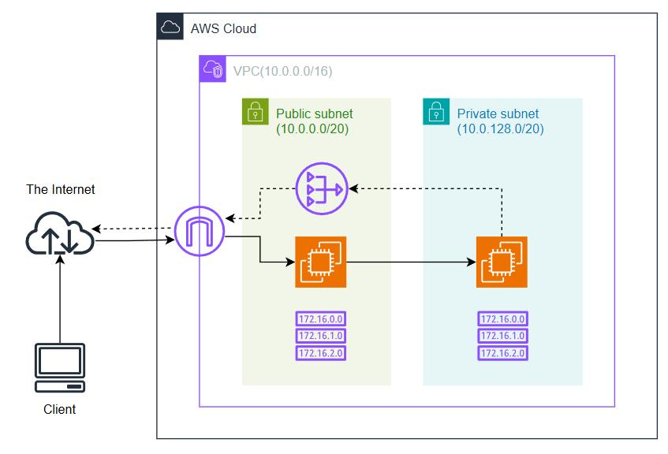
Question 5: AWS VPC Architecture Diagram
Network Diagram
Internet
│
│
+------------------+
| Internet Gateway |
+------------------+
│
InstaVibeVPC
(10.0.0.0/16)
┌────────────────────────┐
│ │
│ │
+--------------------+ +--------------------+
| PublicSubnet | | PrivateSubnet |
| 10.0.1.0/24 | | 10.0.2.0/24 |
| Web Server | | Backend Services |
| Internet Access ✓ | | Database |
+--------------------+ | No Internet ✗ |
Explanation
The VPC contains one public subnet and one private subnet. The public subnet is connected to the Internet Gateway, allowing users to access web applications hosted on it. The private subnet does not have a route to the Internet Gateway, ensuring that backend services and databases remain secure and inaccessible directly from the internet.
Similarity with Zomato
Applications such as Zomato use a similar architecture. Users interact with web servers located in the public subnet, while backend services and databases are deployed in the private subnet. This separation improves security by preventing direct internet access to sensitive customer and application data.
